Day 24 Files Directories and Paths



Snake Game improvements

Keep track of high score

Letter writing app – Personalize part of a letter 

Add high score tracking to Snake Game

Write to a file

The open method

[https://docs.python.org/3/tutorial/inputoutput.html#reading-and-writing-files](https://docs.python.org/3/tutorial/inputoutput.html#reading-and-writing-files)



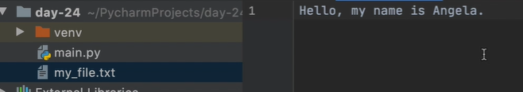

Tracking the high score of snake game in a file

from turtle import Turtle  
ALIGNMENT = "center"  
FONT = ("Courier"**, 24,** "normal")  
  
  
class Scoreboard(Turtle):  
  
 def __init__(self):  
 super().__init__()  
 self.score = **0** #add high score attribute  
 # self.high_score = 0  
 #change this to reading the file to get high score  
 #need to convert to an intiger  
 with open("data.txt") as data:  
 self.high_score = int(data.read())  
 self.color("white")  
 self.penup()  
 self.goto(**0, 270**)  
 self.hideturtle()  
 self.update_scoreboard()  
  
 def update_scoreboard(self):  
 self.clear()  
 self.write(f"Score: {self.score} High Score: {self.high_score}"**,** align=ALIGNMENT**,** font=FONT)  
 def reset(self):  
 if self.score > self.high_score:  
 self.high_score = self.score  
 with open("data.txt"**,**mode="w")as data:  
 #turn it back into a string  
 data.write(f"{self.high_score}")  
 self.score = **0** self.update_scoreboard()  
  
  
 def increase_score(self):  
 self.score += **1** self.clear()  
 self.update_scoreboard()

File Paths and directories

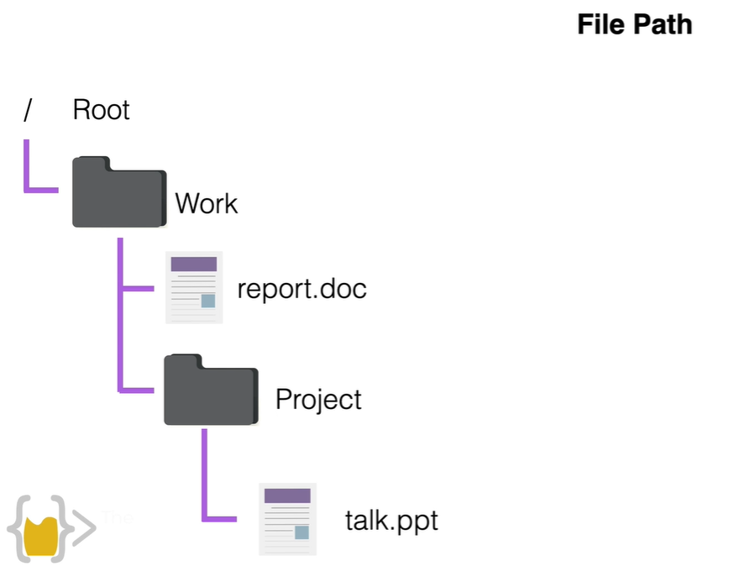

Windows root is C drive 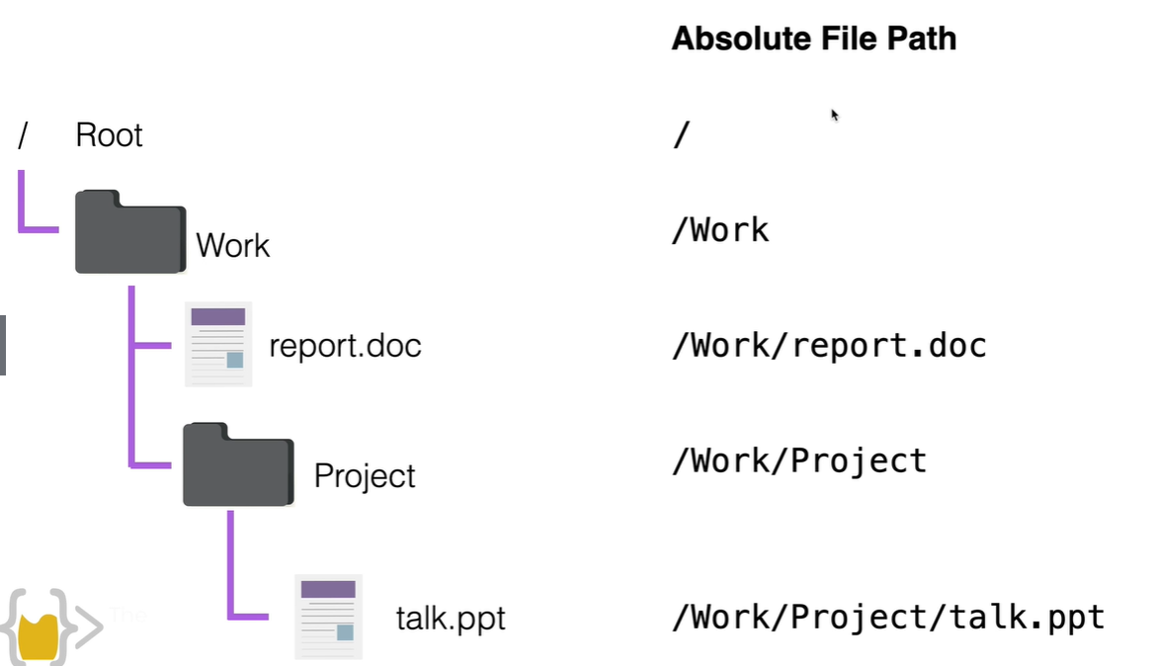

Relative file path – from the working directory

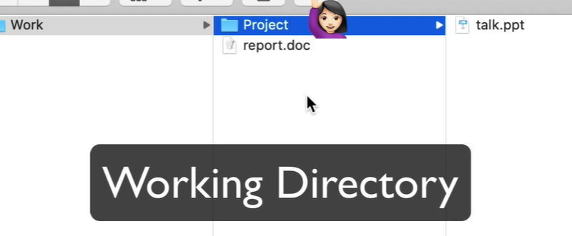

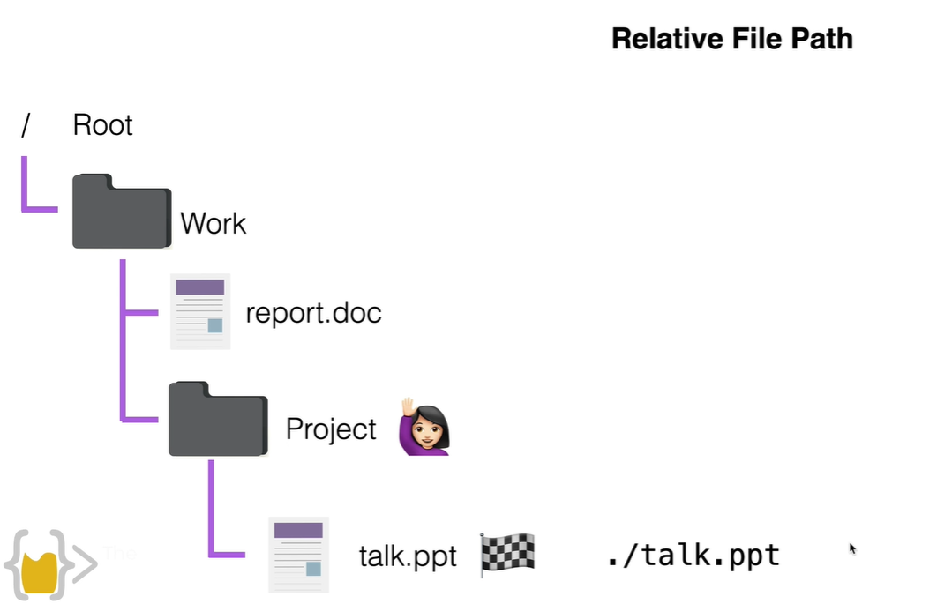

One step up in the relative file path ../

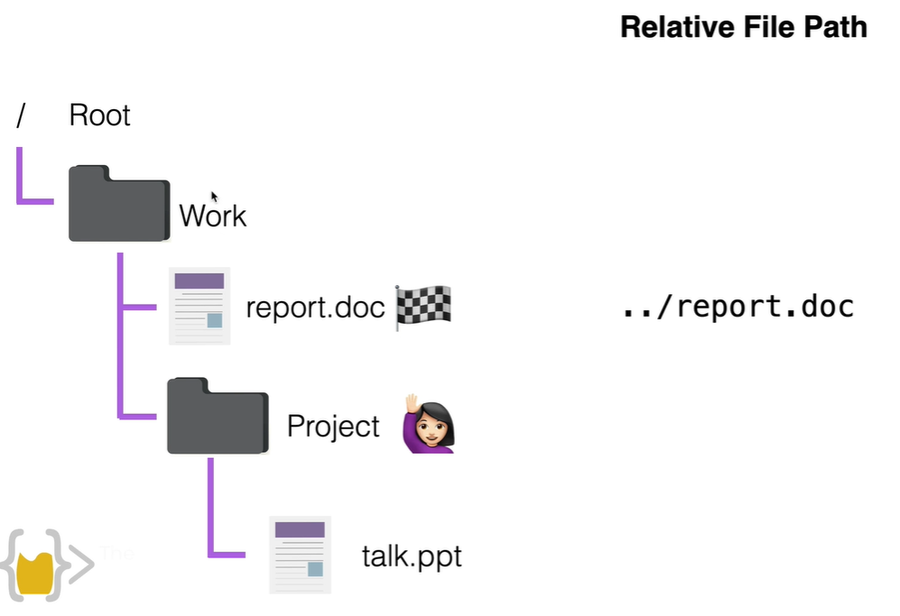

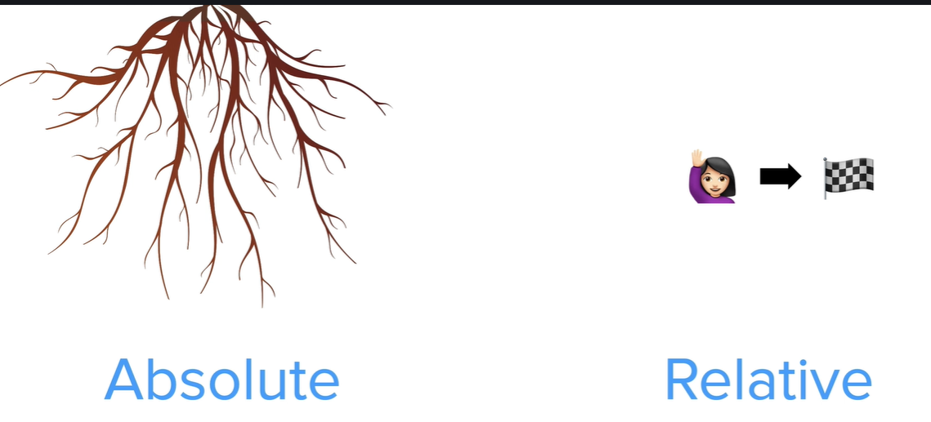

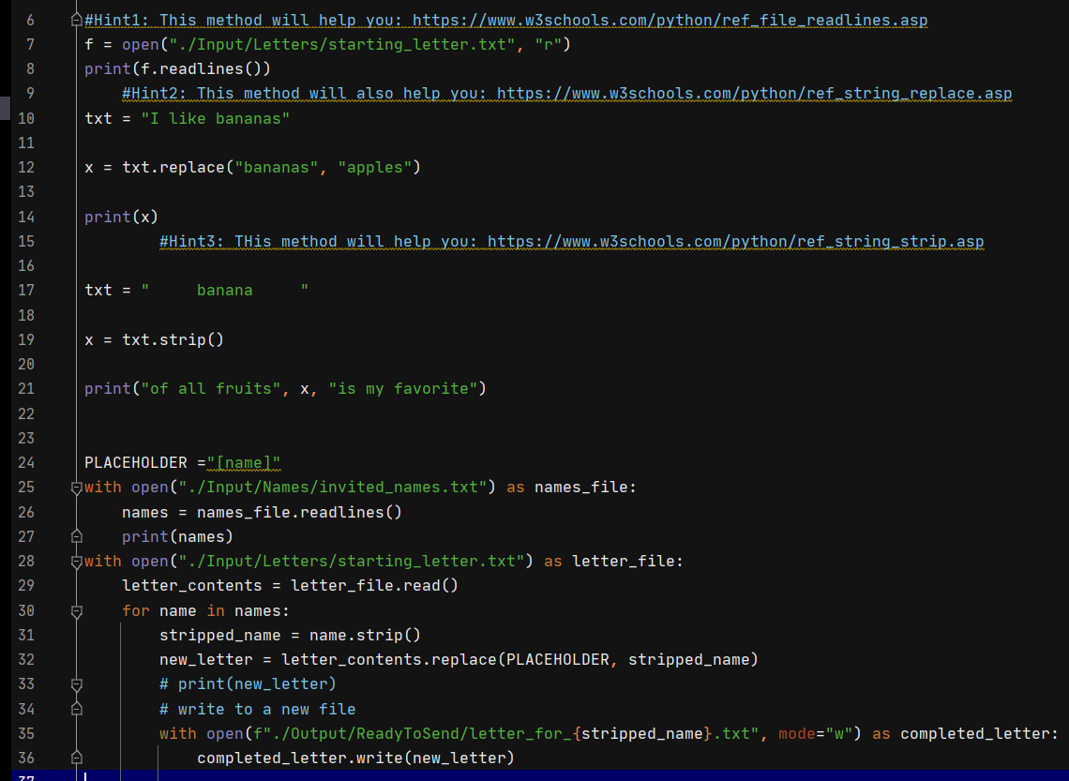

PLACEHOLDER ="[name]"  
with open("./Input/Names/invited_names.txt") as names_file:  
 names = names_file.readlines()  
 print(names)  
with open("./Input/Letters/starting_letter.txt") as letter_file:  
 letter_contents = letter_file.read()  
 for name in names:  
 stripped_name = name.strip()  
 new_letter = letter_contents.replace(PLACEHOLDER**,** stripped_name)  
 # print(new_letter)  
 # write to a new file  
 with open(f"./Output/ReadyToSend/letter_for_{stripped_name}.txt"**,** mode="w") as completed_letter:  
 completed_letter.write(new_letter)